HOW TO REGISTER A TEAM ON BASKETBALLCONNECT
Via a registration link

As a team captain, you can register yourself and create your team by starting here clicking on the registration link you receive from your club or association. If you don’t receive this link, contact your club or association directly.

1 | If you have never used BasketballConnect before, you will need to create a profile so select New User – Register  If you have previously registered for a competition on BasketballConnect, enter your login details and your personal details will pre-populate for you.
 | 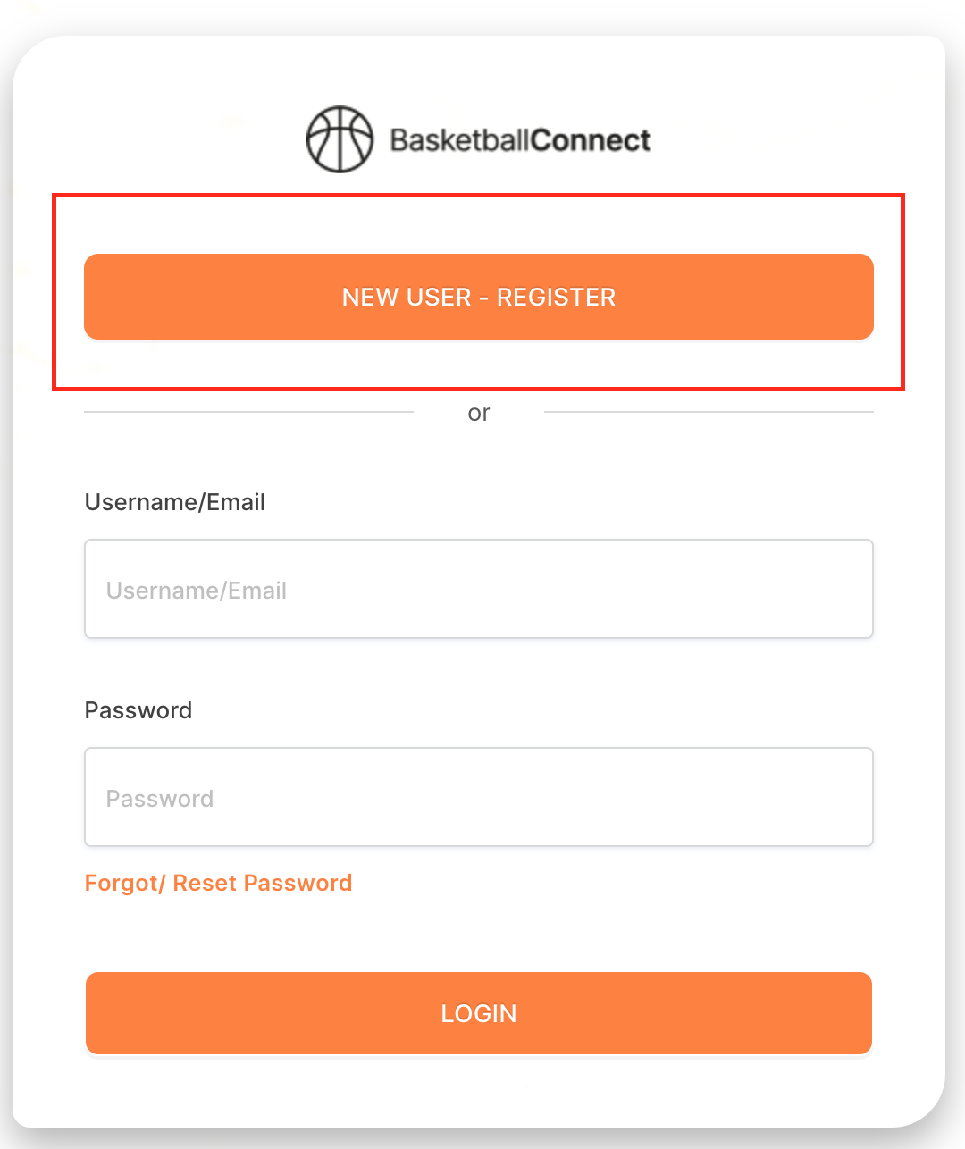

2 | Here you will need to select + New Team Registration
 | 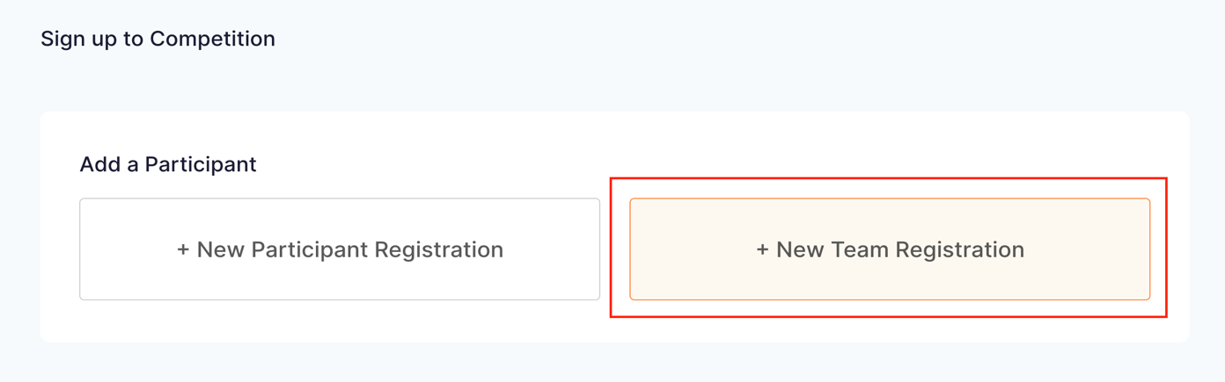
3 | This will display the competition you are registering to
 | 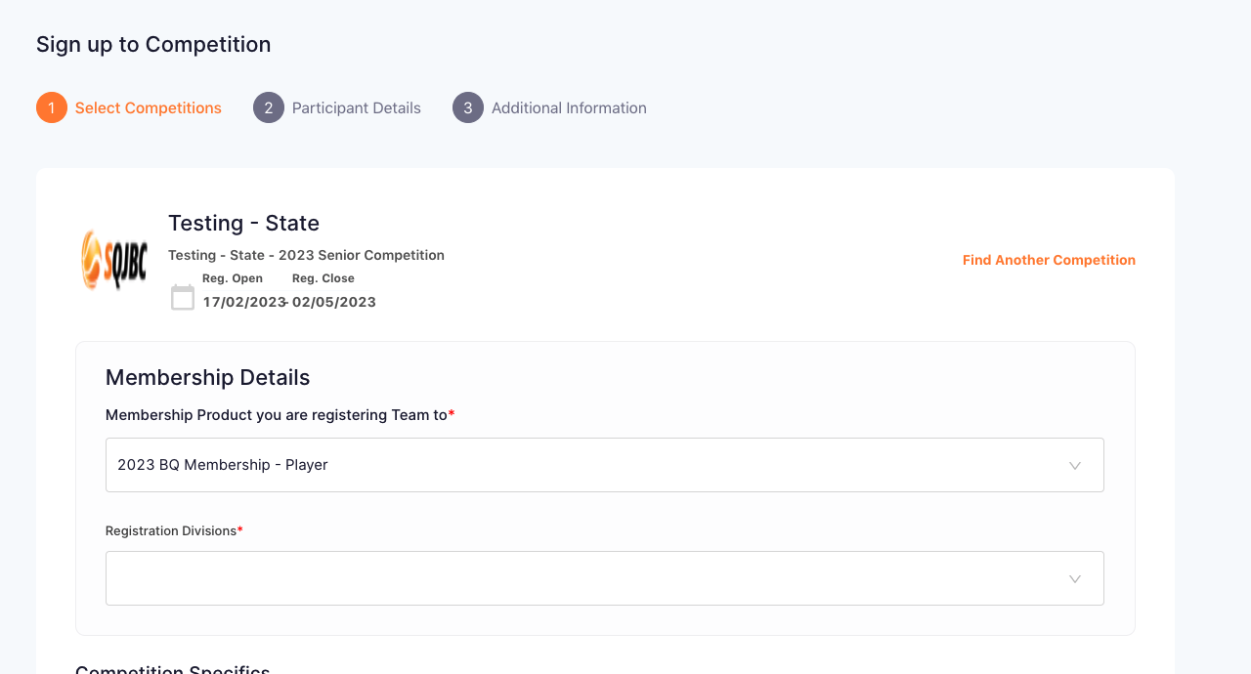

4 | From the drop-down menu, select your division from the displayed options
 | 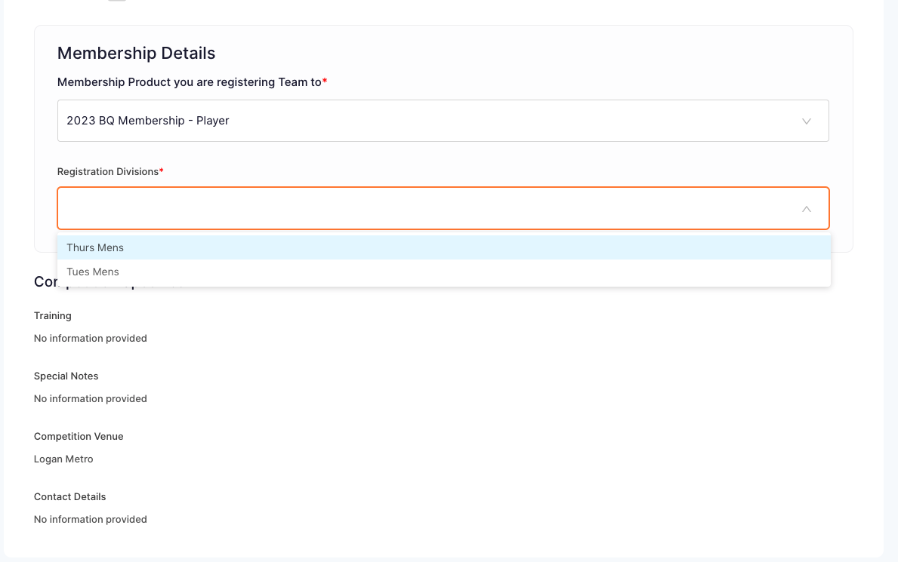
5 | Scroll down to select Sign Up to Competition
 | 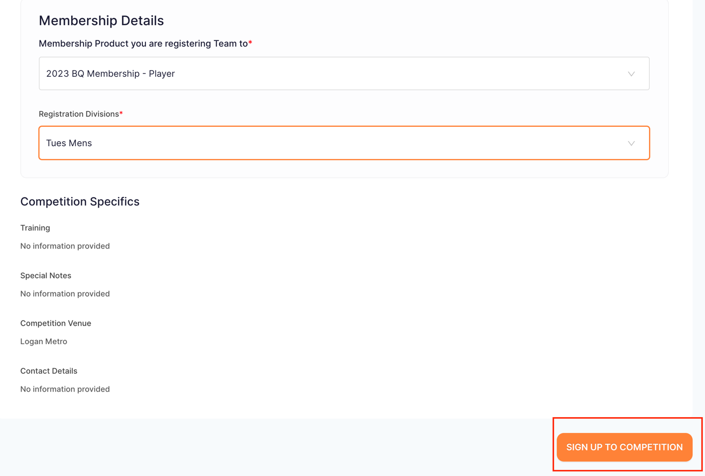

6 | As the team captain, select Player then enter your personal details  If you have a Game Day profile, ensure you enter your details exactly as they were in Game Day:  First Name  Last Name  Phone Number  Email Address  This will offer you a profile to claim
 | 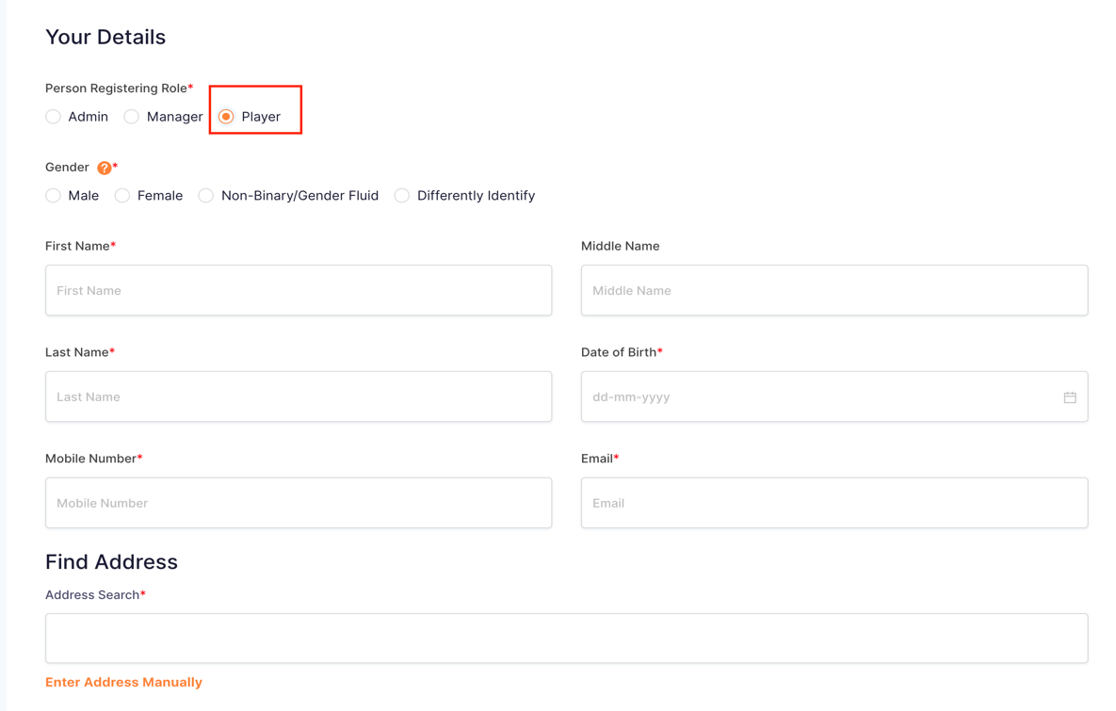
7 | Confirm your email address
 | 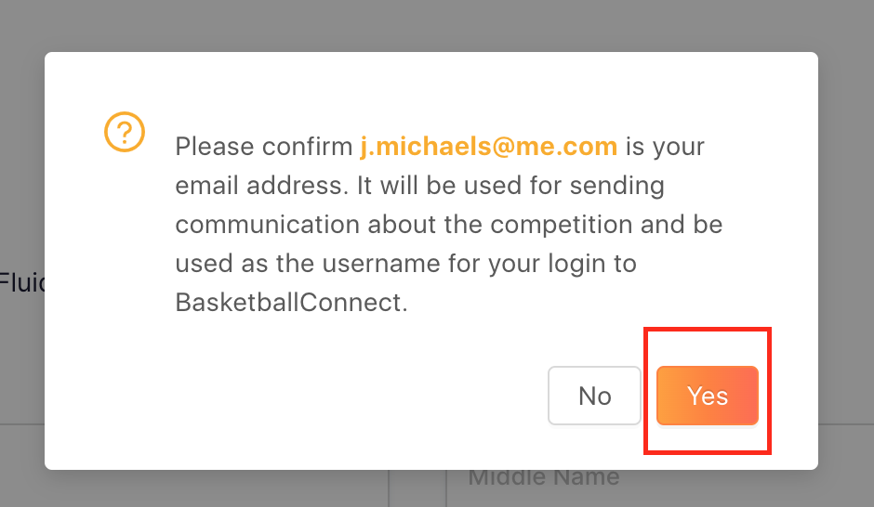

8 | If you have entered your details to match Game Day, a pop-up will offer you a profile to claim  Follow the prompts to claim your BasketballConnect profile which will include your current BQ membership information
 | 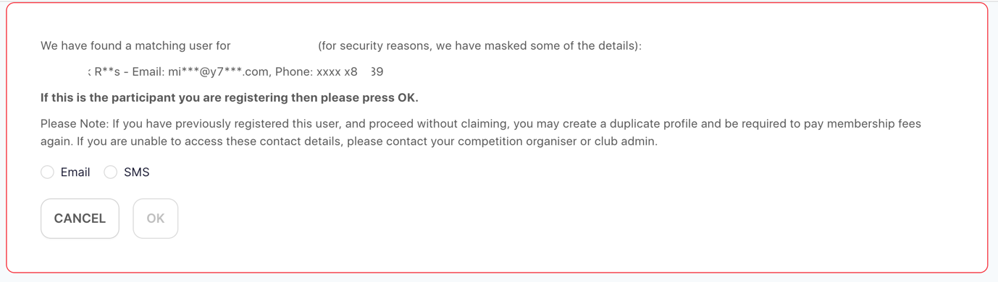
9 | Type your address and select from the displayed options
 | 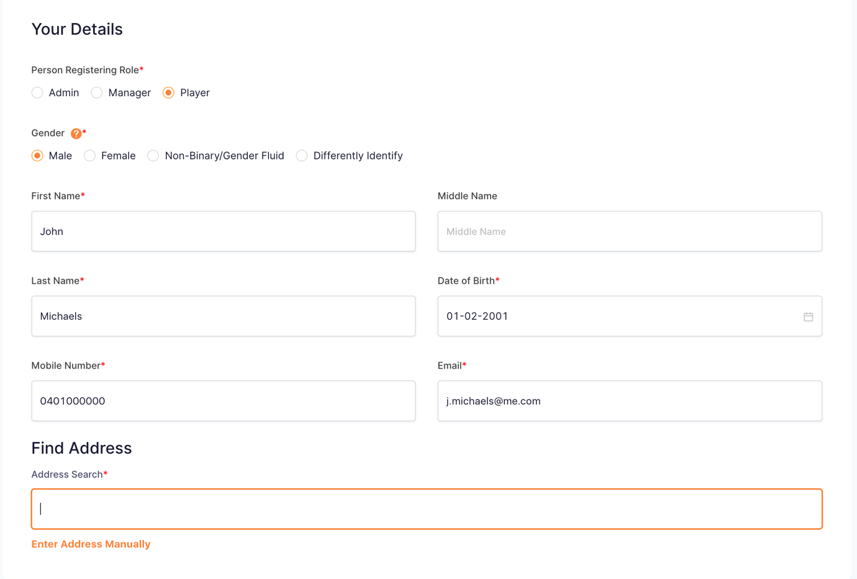

10 | After entering your emergency contact’s details, enter your Team Name
 | 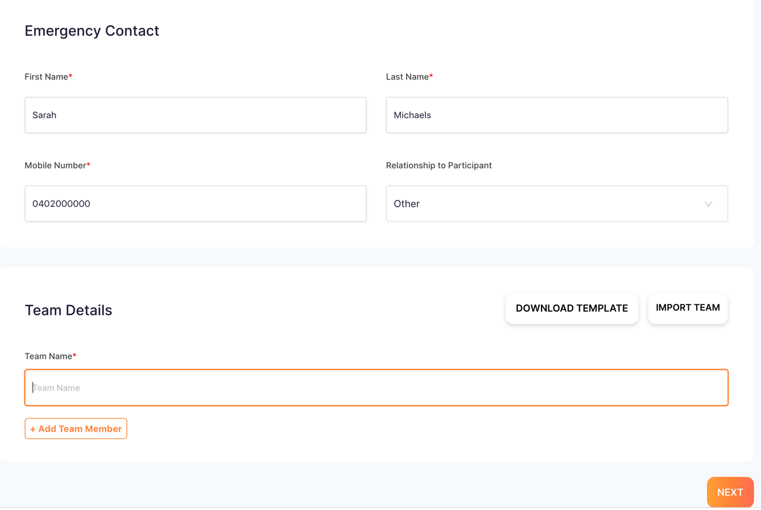
11 | To add team members to your team, select + Add Team Member  Once you have completed your team registration, each team member will receive an email inviting them to complete their registration to the team
 | 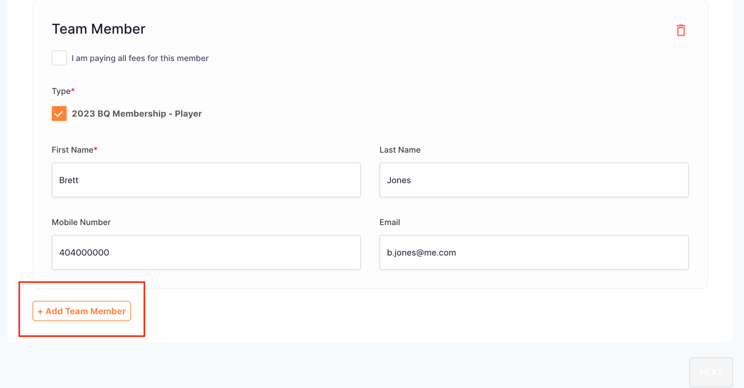

12 | Enter the team member’s details as prompted  Once all your team members have been added, select Next
 | 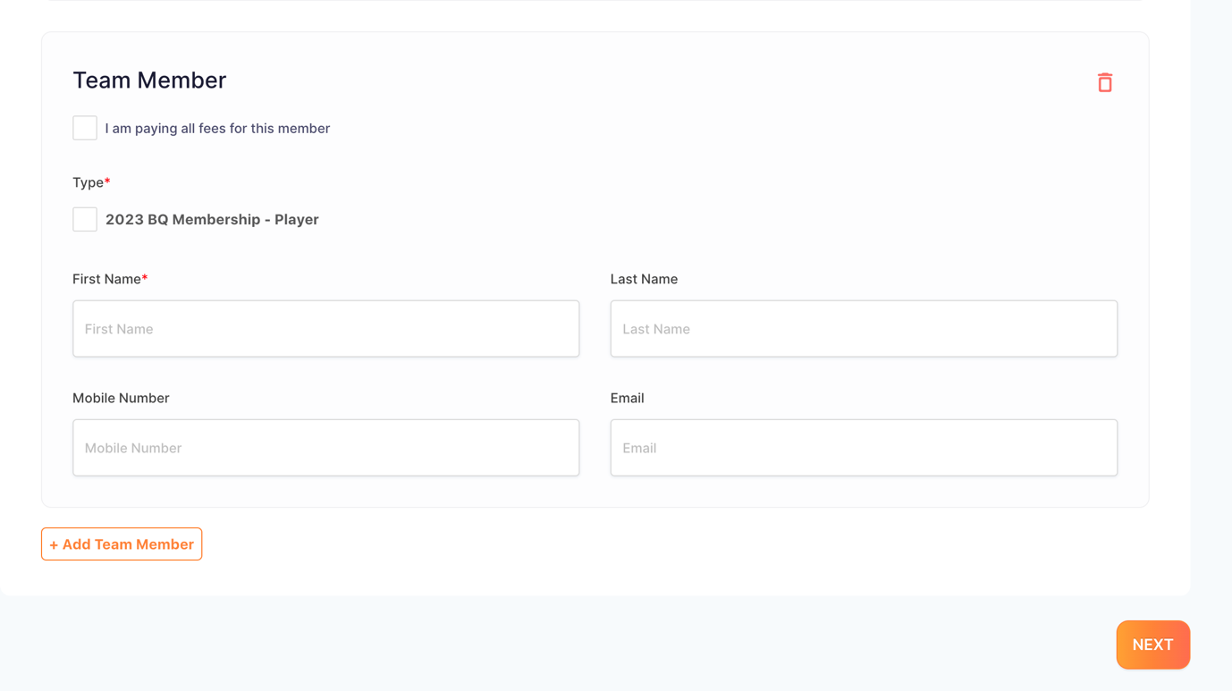
13 | Enter the information in the required fields
 | 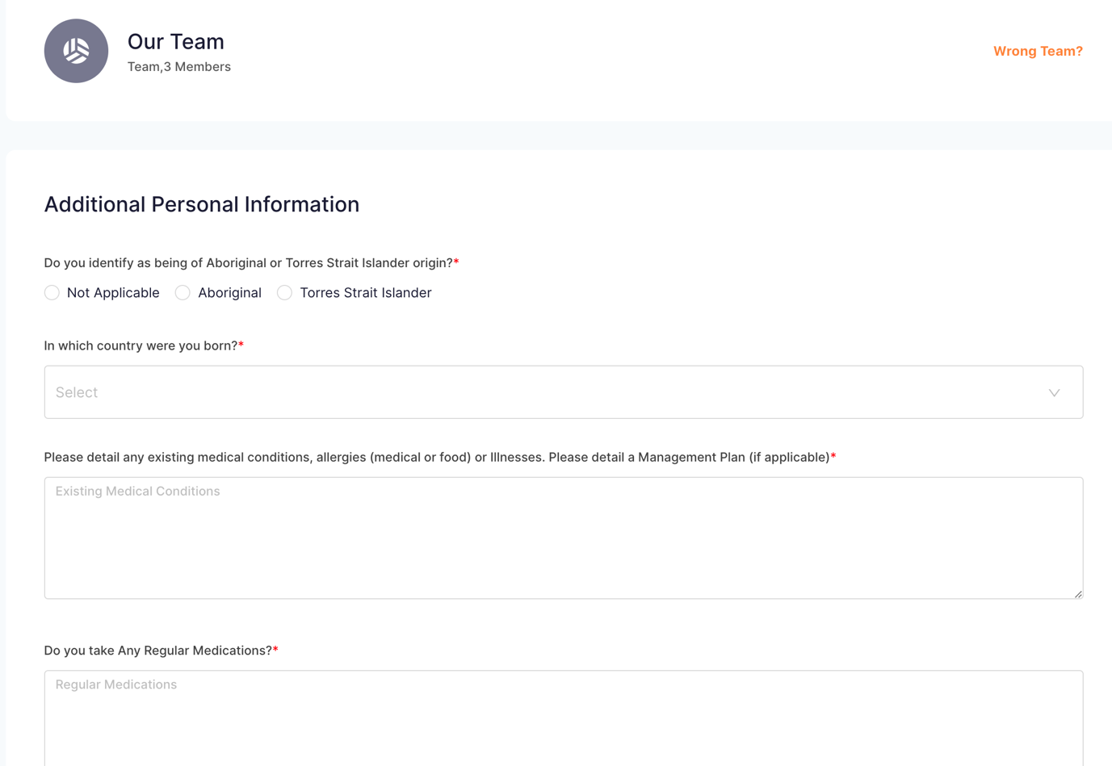

14 | Once you have completed the required fields, select Sign Up to Competition
 | 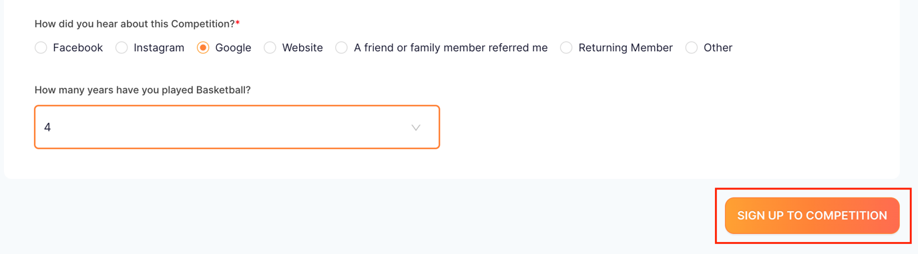
15 | The next screen will show you a summary of your registration
 | 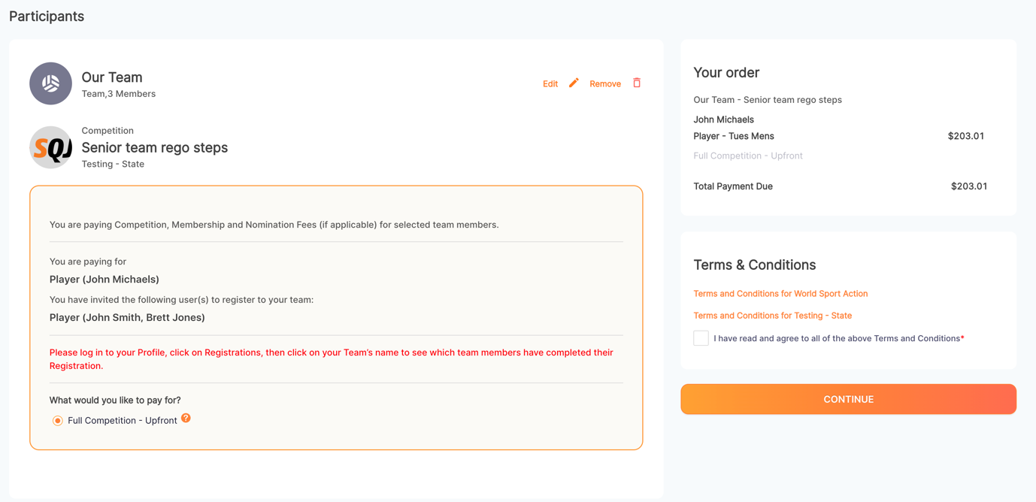

16 | Ensure you indicate that you agree to any term and conditions supplied before selecting Continue
 | 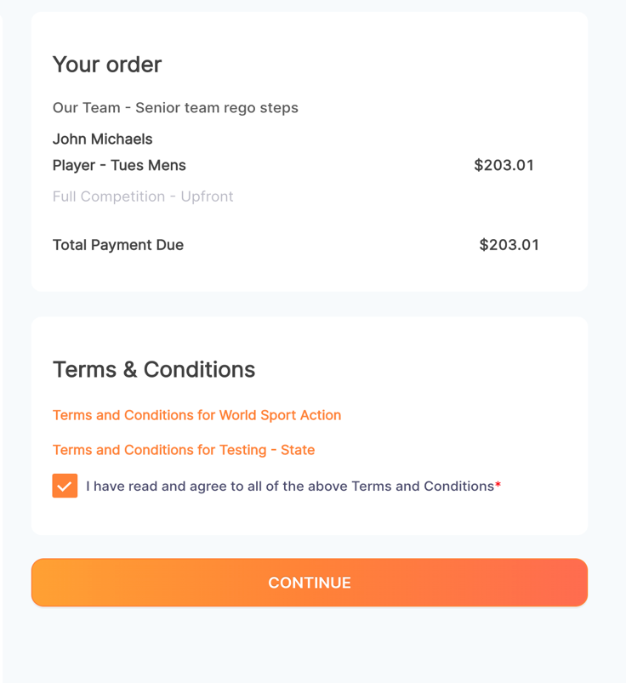
17 | If you are paying by Direct debit, enter your bank account information then select Submit
 | 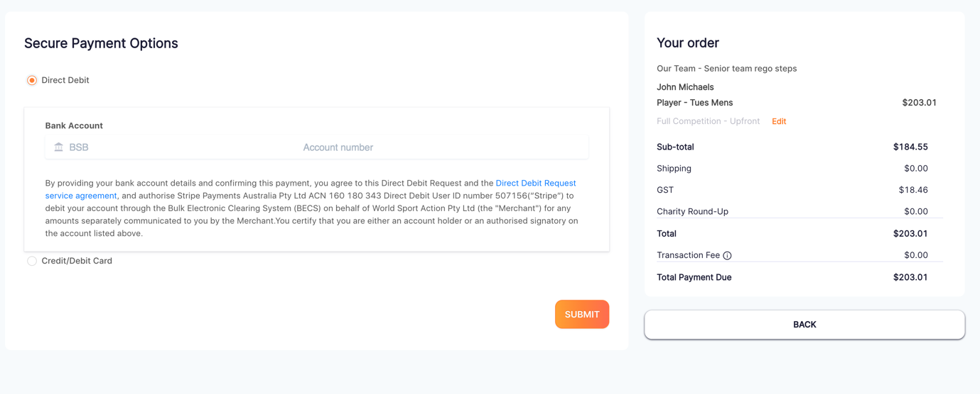

18 | If you are paying by Credit card, enter the details then select Submit
 | 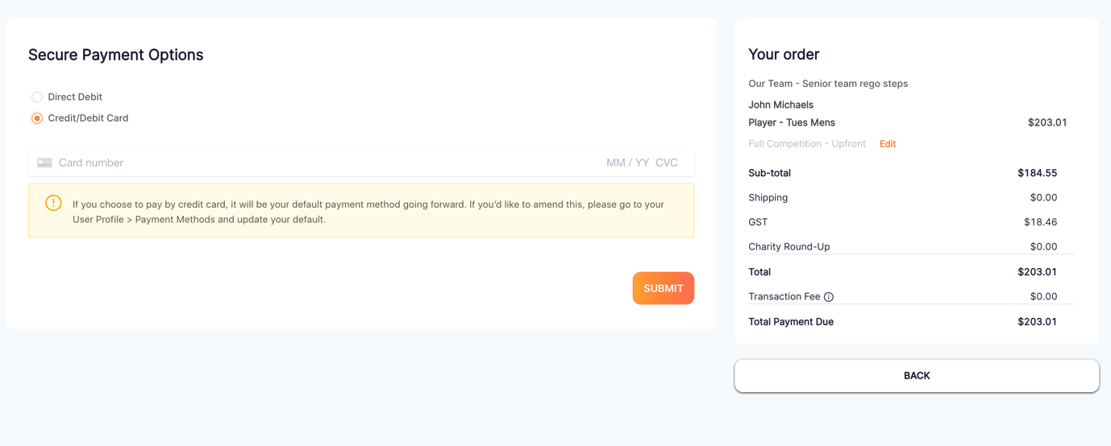
19 | You will then receive an email with login instructions  Follow the link to login to your BasketballConnect account
 | 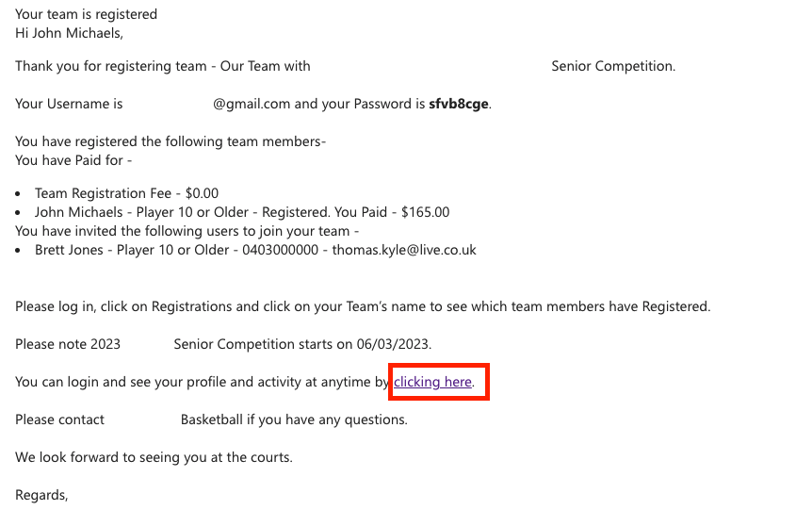

20 | Enter your login details as mentioned in the email then select Login
 | 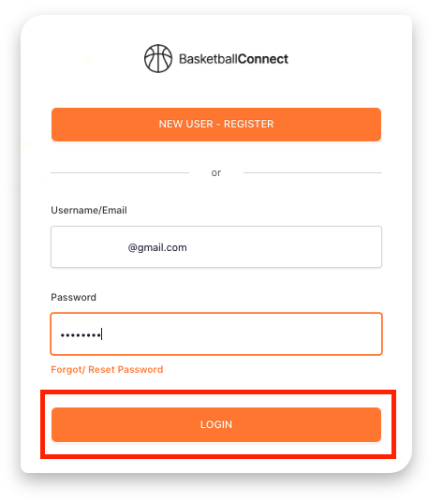
21 | Your user profile will display like this.  Please refer to our User Guide for more information regarding your profile
 | 