HOW TO COMPLETE A TEAM MEMBER REGISTRATION
Via email initiation

If you have received an email inviting you to complete your team registration, follow the steps below:
1 | The email will contain a link which will take you to the registration form.
 | 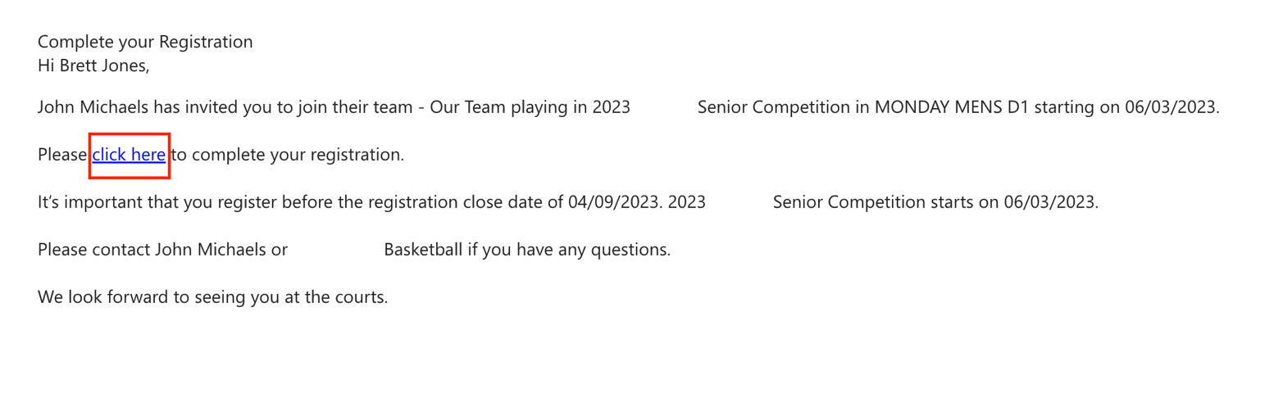
2 | If you have not competed in a competition using BasketballConnect before, select New User – Register  If you have previously used BasketballConnect, enter your login details
 | 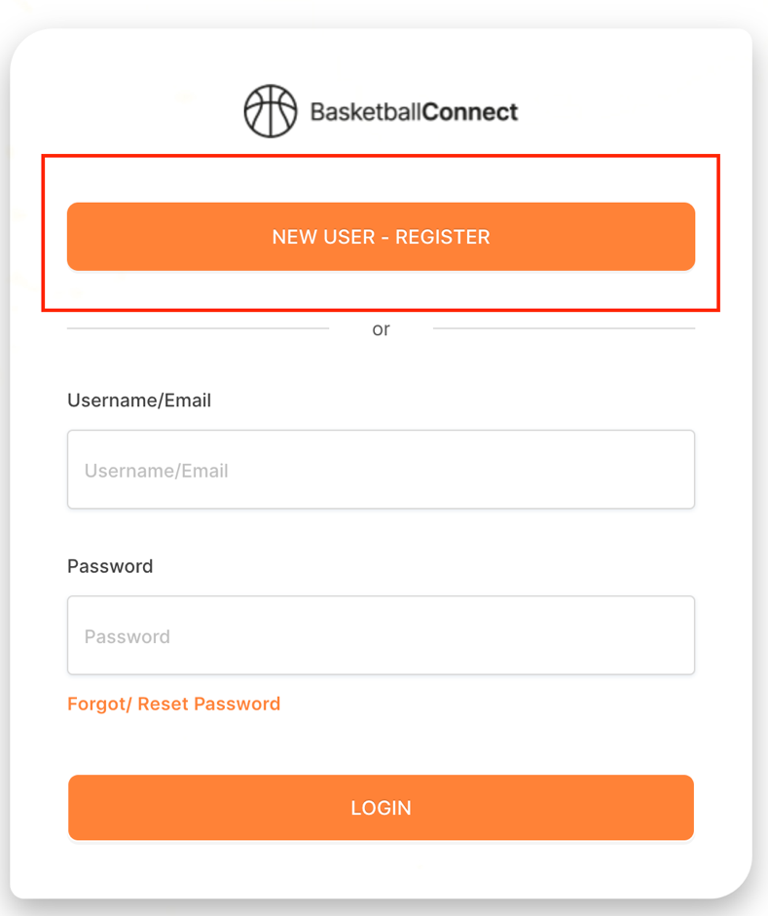

3 | The competition details will appear on the screen
4 | If you have a Game Day profile, ensure you enter your details exactly as they were in Game Day:  First Name  Last Name  Phone Number  Email Address  This will offer you a profile to claim
 | 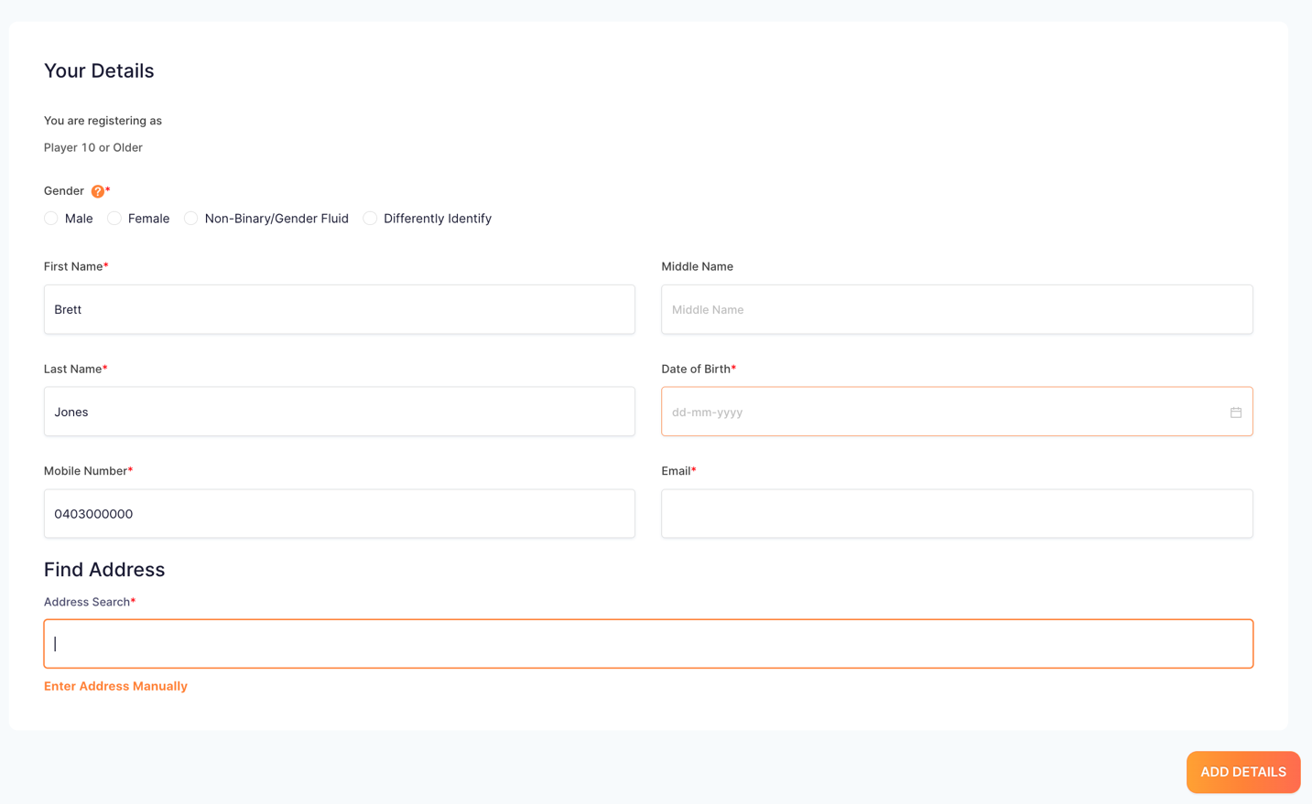

5 | If you have entered your details to match Game Day, a pop-up will offer you a profile to claim  Follow the prompts to claim your BasketballConnect profile which will include your current BQ membership information
 | 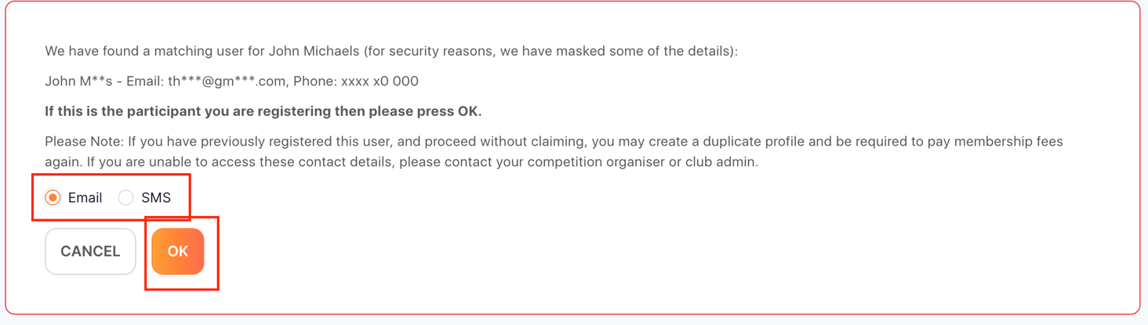
6 | Confirm your email address

7 | Once your profile has been claimed, select Next
8 | Enter your emergency contact details then select Add Details
 | 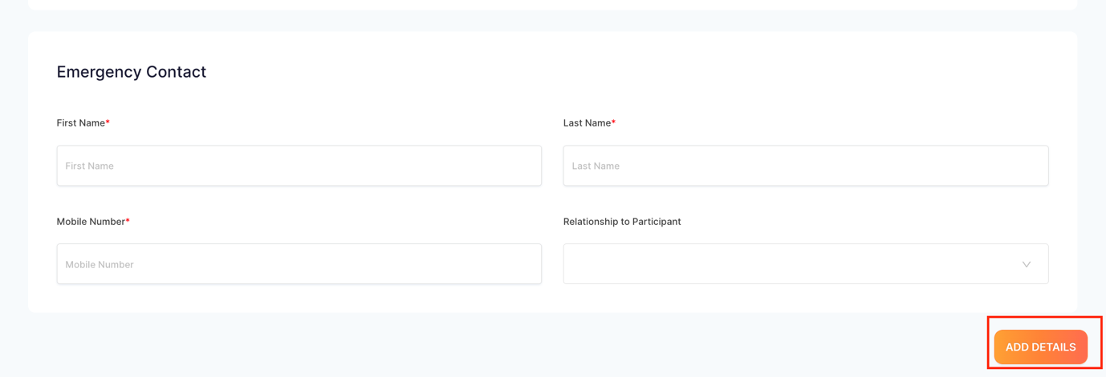

9 | Enter the details in the required fields then select Review Order
 | 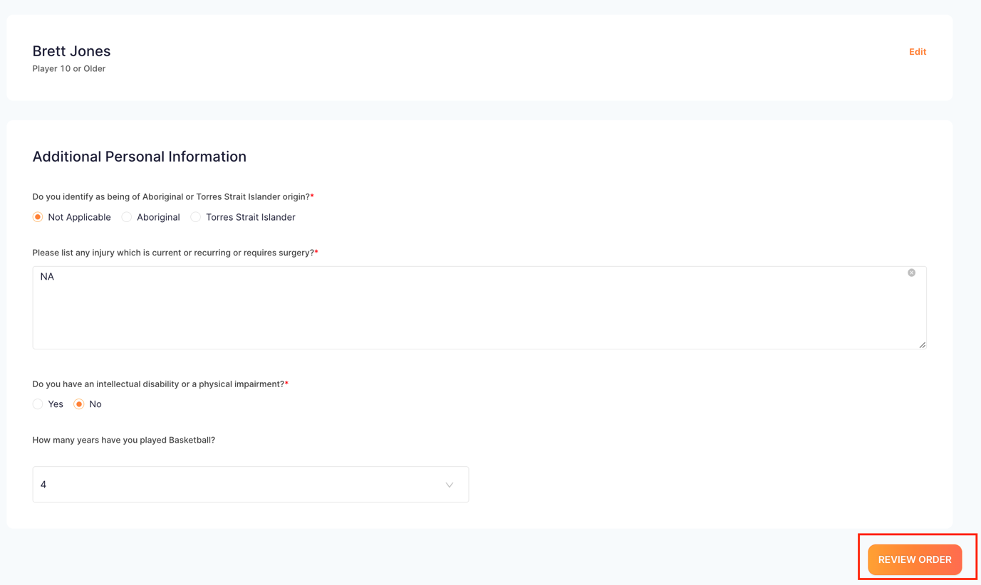
10 | This screen will give you a summary of your registration  Ensure you agree to the Terms and Conditions before continuing to the payment screen
 | 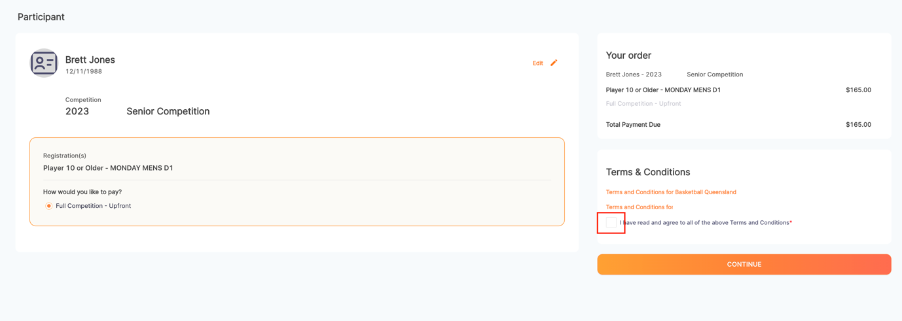

11 | If you are paying by Direct Debit, enter your bank details then select Submit
 | 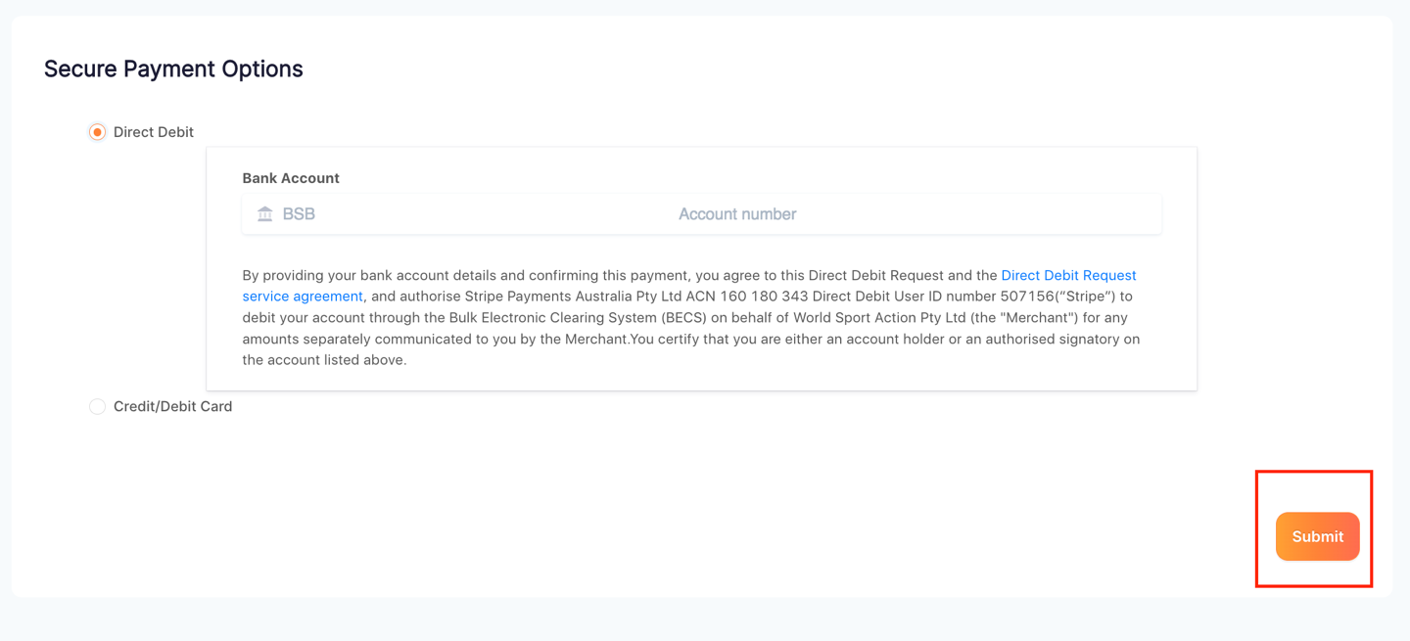
12 | If you are paying by Credit Card, enter the details then select Submit

